29th April 2025

Dear Parents/Carers,

As I am sure you will be aware, this week will see temperatures reach as high as 25°C in Sheffield. Due to this, we wanted to write to remind you about how you can support your child/ren and the academy during the hot weather:

• Send your child to school with a labelled bottle of water which they can freely drink from and refill during the day.

• Pack a sun hat or cap in your child’s book bag which they can wear at break and lunch times.

• Show your child how to apply sun cream. This can be brought into school for them to reapply themselves. Please make sure this is labelled and placed into your child’s book bag.

• Please ensure all jumpers are clearly labelled with your child’s name.

As always, we will be encouraging children to seek shelter from the sun during breaks, lunchtime, and at play in general.

We appreciate your support in ensuring that children stay safe and comfortable during the summer season. In the meantime, if you have any questions, please do not hesitate to speak to your child’s class teacher.

Many thanks for your continued support

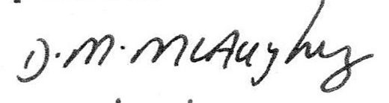

Dawn McAughey

Headteacher