PE Funding

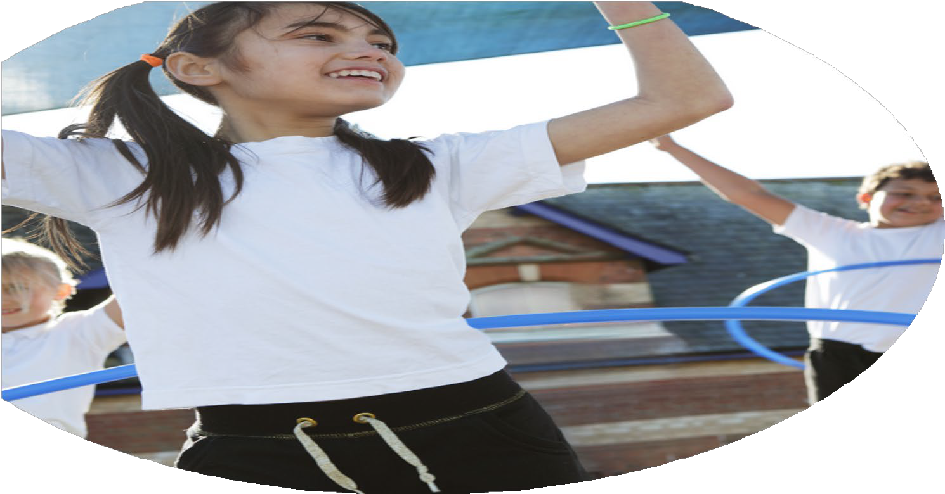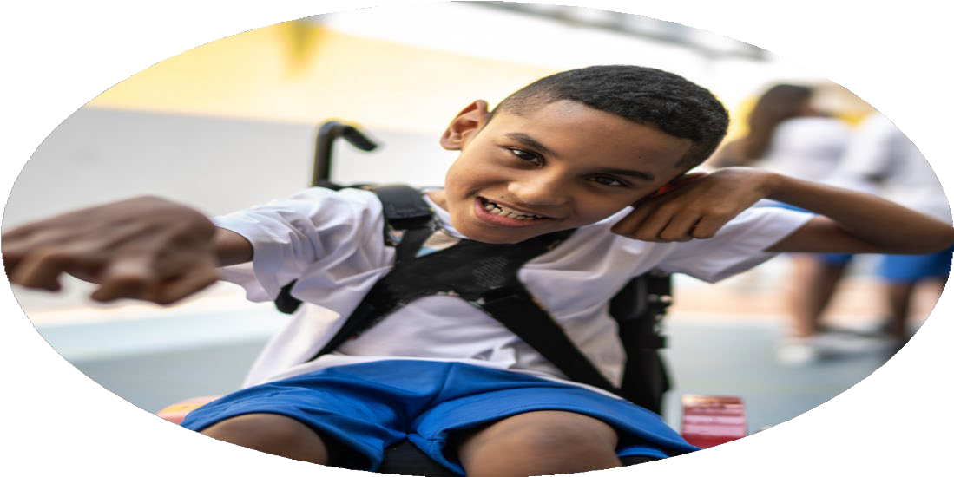

Evaluation Form

**Commissioned by**

**Created by**

Images courtesy of Youth Sport Trust

**We recommend that you start by reflecting on the impact of current provision and reviewing your previous spend**

|  |  |  |  |
| --- | --- | --- | --- |
| What went well? | How do you know? | What didn’t go well? | How do you know? |
| Last year, all children had the opportunity to take part in physical activity at break time and lunch time independently using a range of equipment and playground markings or in a more led activity by sports leader children, lunchtime supervisors, teachers and coaches.  Children are encouraged to take part in extra-curricular PE clubs where possible with the opportunity to work towards a competition or event should they wish. | Children have access to a range of equipment and know to play safely and with consideration for others. Children and staff recognise a vast range of benefits of sport and physical activity including our physical, social and mental health.  Children recognise the benefits and the importance of sports and physical activity on their academic learning and school life. Children enjoy attending clubs regularly whether it be for fun or a more competitive element. | Reaching more targeted groups out of school time. | Little uptake and very little attendance of after school clubs by targeted children including those less active and PP. |

|  |  |
| --- | --- |
| What are your plans for 2024/25? | How are you going to action and achieve these plans? |
| Intent | Implementation |
| An increase in focus of tailored activities for pupil premium children in and out of school time.  Detailed weekly planning readily available for all staff on all sports and activities on the long term plan. | Organise PP specific groups for a variety of activities in school time. |

|  |  |
| --- | --- |
| What impact/intended impact/sustainability are you  expecting? | How will you know? What **evidence** do you have or  expect to have? |
| PP children have access to sports and activities that they otherwise aren’t able to attend out of school time.  Staff are increasingly familiar with the delivery of a wide range of lessons relevant for their Key Stage/Year Group. Children are more confident and competent across their range of PE lessons. | PP children uptake and pupil and staff voice. |

|  |  |
| --- | --- |
| What **impact/sustainability** have you seen? | What **evidence** do you have? |
| We have managed to deliver for many more children by offering PP children opportunities during school time. They enjoy their time and develop many essential skills in the practical, social situations.  Staff are much more confident in feeling equipped to deliver the broad curriculum to a good standard after using the planning scheme. | PP children uptake and pupil and staff voice. |