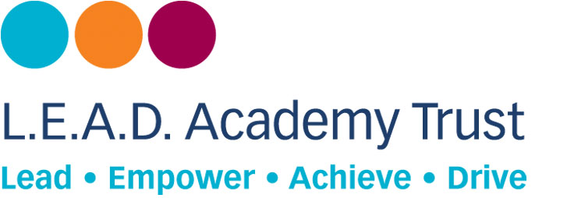
Private and confidential

Equality and diversity monitoring

L.E.A.D. Academy Trust is committed to equal opportunities in employment regardless of age, gender, disability, sexual orientation, marital status, race/ethnic origin, nationality, religion or belief, pregnancy/maternity or gender reassignment. It is our policy to ensure that individuals are recruited, developed and promoted on the basis of their ability and the requirements of the job role.

This monitoring form is voluntary but the information we collect here is very useful to us as it helps us to make sure that we are an inclusive employer and evaluate the effectiveness of our Equal Opportunities Policy. The information you supply will be treated in the strictest confidence.

Name:

Job Role:

School/department:

Age

☐ 16 - 24 | ☐ 25 - 34 | ☐ 35 - 44 | ☐ 45 - 54 | ☐ 55 - 64 | ☐ 65+ | ☐ Prefer Not to Say

Gender

☐ Female | ☐ Male | ☐ Prefer Not to Say | ☐ If you prefer to use another term, please specify here…

Disability and health

The Equality Act 2010 defines disability as 'A physical or mental impairment which has a substantial and long term adverse effect on a person's ability to carry out normal day to day activities.' Long term in this context means likely to last longer than 12 months or likely to recur.

Do you consider yourself to have a disability as defined by the Equality Act 2010?
☐ No | ☐ Yes | ☐ Prefer Not to Say

Do you have any long-term illness, health problems or disability that, with or without the use of aids or medication, would limit your ability to fulfil your job role?
☐ No | ☐ Yes | If yes, please provide brief details
This information may be shared in confidence with relevant managers, in order to make them aware of any reasonable adjustments we may need to consider making.

Sexual Orientation

☐ Bisexual | ☐ Gay | ☐ Heterosexual | ☐ Lesbian
☐ Prefer Not to Say | ☐ If you prefer to use another term, please specify here…

Marital Status

☐ Divorced | ☐ Married/Civil Partnership | ☐ Partner | ☐ Single
☐ Separated | ☐ Widowed | ☐ Prefer Not to Say

Ethnic origin

Ethnic origin categories are not about nationality, place of birth or citizenship. They are about the group to which you perceive you belong.

White
☐ White - British | ☐ White - Irish | ☐ Any Other White Background

Mixed/Multiple Ethnic Groups
☐ White and Asian | ☐ White and Black African | ☐ White and Black Caribbean | ☐ Any Other Mixed Background

Asian/Asian British
☐ Bangladeshi | ☐ Indian | ☐ Pakistani | ☐ Any Other Asian Background

Black/Black British
☐ Black African | ☐ Black Caribbean | ☐ Any Other Black Background

Other Ethnic Group
☐ Chinese | ☐ Gypsy/Roma | ☐ Traveller of Irish Heritage
☐ Any Other Ethnic Background, please specify here… |  |  | ☐ Prefer Not to Say

Religion

☐ Buddhist | ☐ Christian* | ☐ Hindu | ☐ Jewish
☐ Muslim | ☐ Sikh | ☐ No Religion or Belief | ☐ Prefer Not to Say

☐ Other religion or belief, please specify here…
*includes Church of England, Catholic, Protestant and all other Christian denominations

Form updated June 2019

